Slider upgrade

命令的执行：

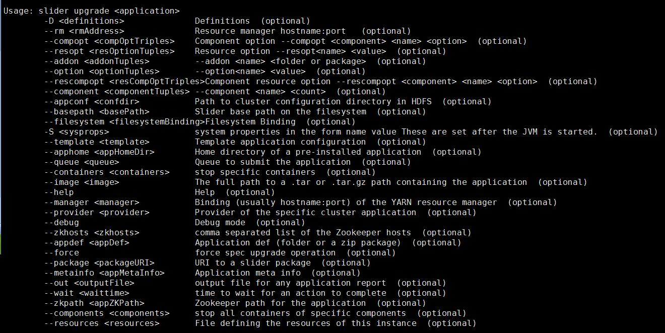

SliderClient#actionUpgrade

—> 获取参数，如template,resources,containers及components

—> 判断是否在命令中，传入template,resources

YES —> buildInstanceDefinition //将参数实例化到hdfs中

—> 调用SliderClusterOperations#amSuide //重新启动AppMaster

NO —> SliderClient#actionUpgradeContainers //upgrade 具体的containers

—> SliderIpcService#upgraderContainers //

—> SliderAppMaster#onUpgradeContainers

—> AgentProviderService#addUpgradeContainers //setInUpgradeMode

AgentProviderService#handleHeartBeat

—> componentStatus#setTargetState : State.UPGRADED

—> #getNextCommand : Command.UPGRADE

—>#addUpgradeCommand

—>buildCommandConfigurations

Upgrade的执行：

—> ActionQueue.py#execute_command

—>CustomServiceOrchestrator.py#runCommand

—> #dump_command_to_json //将appconfig中的参数实例化命令中

—>{script}#PRE_UPGRADE，例如tomcat.py#PRE_UPGRADE

//但是没有前期的准备，导致该命令运行失败，但是hbase.py中是由该方法的

—>{script}#POST_UPGRADE

—>{script}#UPGRADE_STOP //stop agent

附：

执行Upgrade的操作流程

1）Pre-upgrade hook: 执行简单的housekeeping tasks，在upgrade中要执行stop操作

2）Post-upgrade hook，在启动新版本的应用组件前做准备